How does prestudy relate to Traffic Light System (TLS) or the Aim step?
Progression note
This article is relevant for those in Technique Training or beyond.
Evaluating prestudy vs. inquiry-based learning systems
What is prestudy?
Prestudy is any study before your main learning event (usually a class, lecture, or intensive dedicated study session). It is usually brief and helps you to familiarise yourself with the new material. This primes our brain and makes future, more detailed learning sessions more manageable and less overwhelming.
Note: Prestudy is not always brief. Learn more about the nuances of this in the Guide to Prestudying correctly.
What is inquiry-based learning?
Inquiry-based learning (IBL) is a method of learning that involves asking questions and stimulating curiosity. The theory is that the learner builds knowledge by consuming and processing information as part of answering these questions and exploring the topic.
The Traffic Light System (TLS) taught in Technique Training is a simple version of IBL which is expanded upon in the Bear Hunter System (taught in the Ascent stages).
Side note: Debates and contentions about IBL
The confusion between prestudy and IBL steps
Some learners can be confused as to how the steps in TLS or Aim relate to the concept of doing prestudy.
This is because both the early stages of IBL methods and prestudy aim to:
- Find basic relationships through active exploration of the topic
- Create simple networks and schemas
- Create big-picture understanding quickly
However, the two are not the same.
- Prestudy is about when we learn. It is a chronological step in studying that simply defines an act of studying done before an intensive main learning event (usually one that is prone to overwhelm such as a fast lecture). Prestudy using the wrong methods can be a waste of time.
- IBL methods such as TLS and the Aim step are about how we learn. They are cognitive steps of the learning process that should happen to develop deep knowledge and memory more efficiently. This process should ideally begin in prestudy but also carry on for subsequent study sessions until the topic has been adequately encoded.
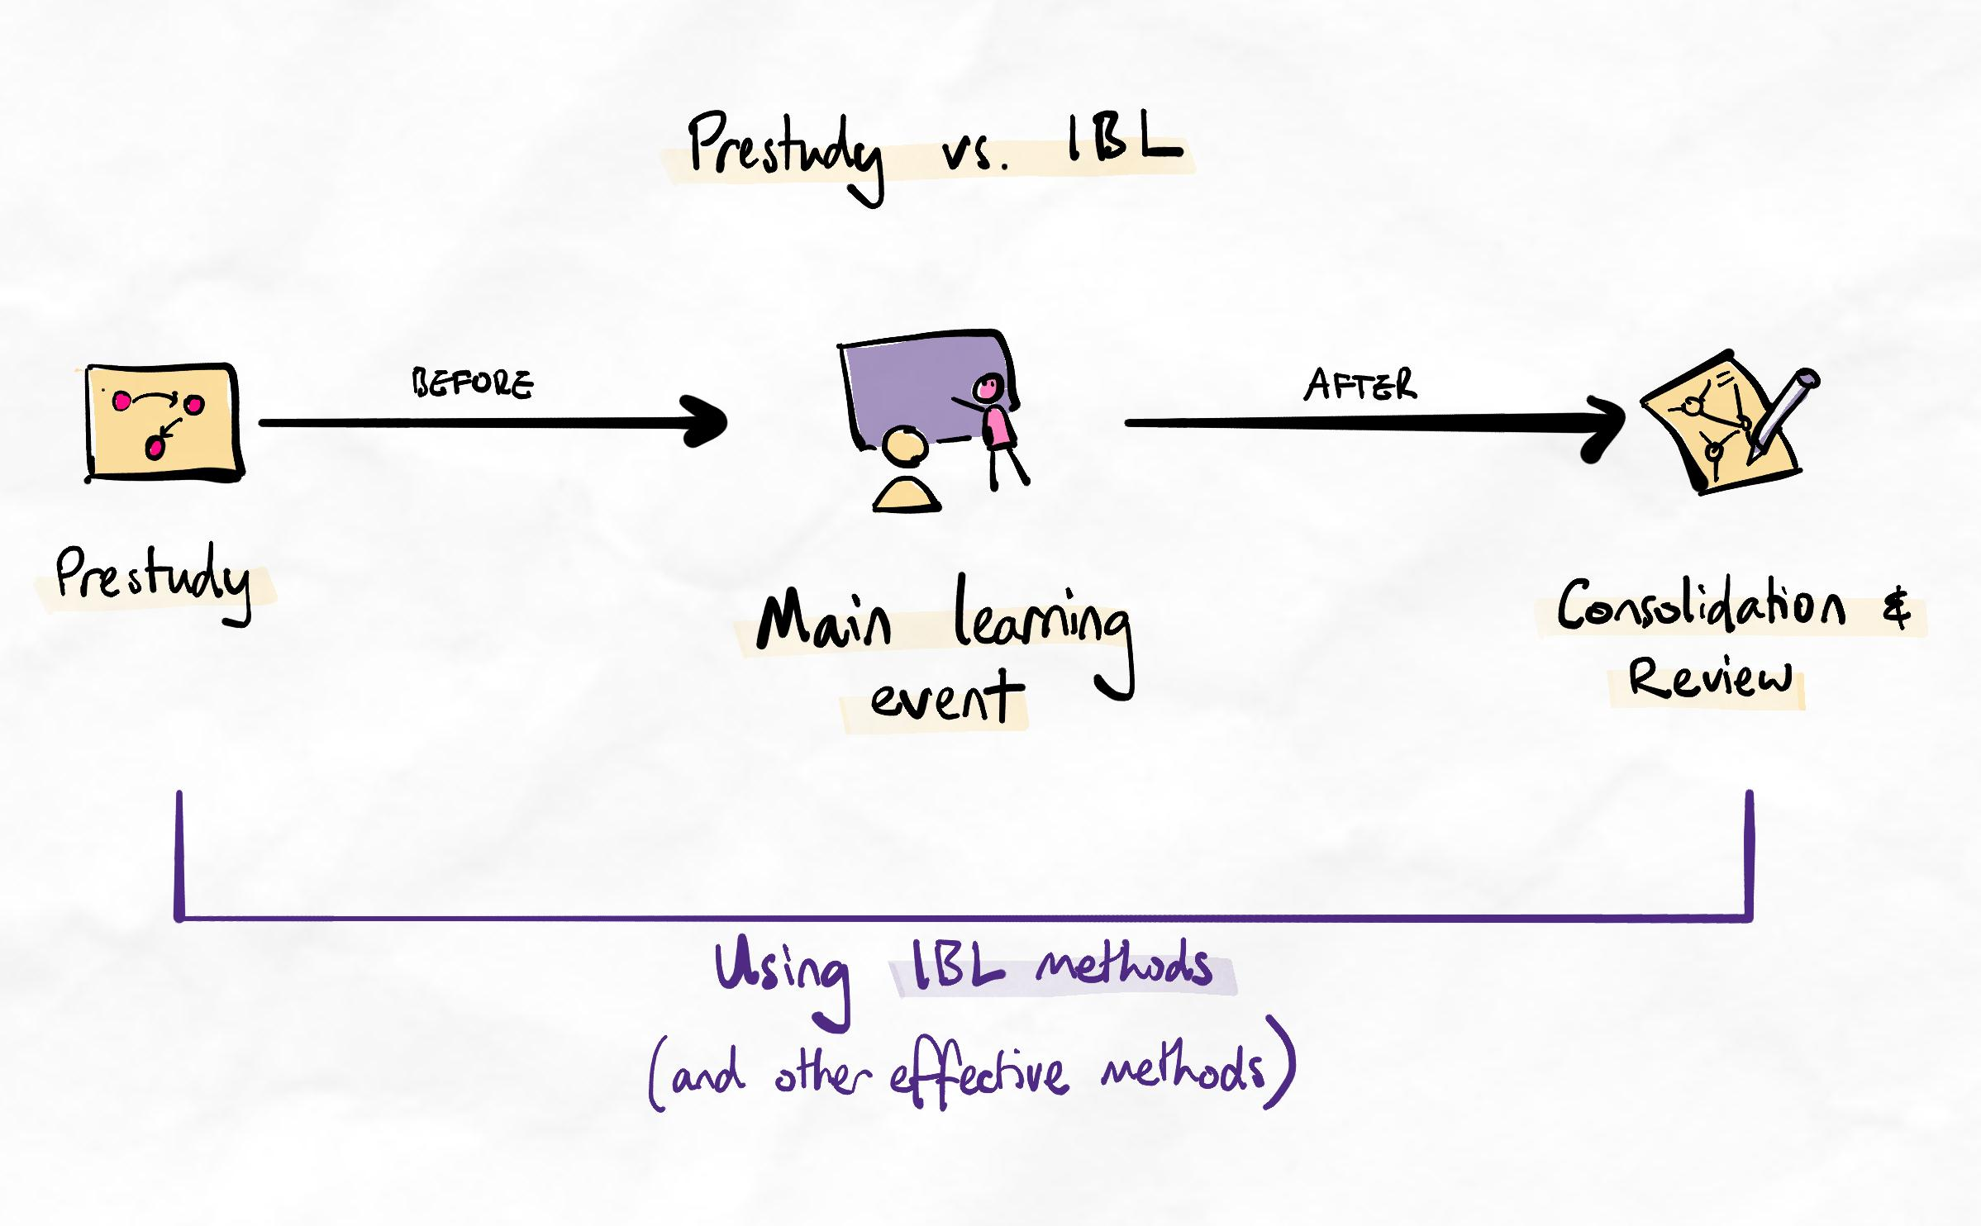Prestudy vs. IBL methods
Practical considerations
No prestudy
Ideally, IBL methods should be used during prestudy to form a basic understanding of the topic.
However, due to other reasons (e.g. time constraints), this may not be possible. If no prestudy is performed, the IBL methods will need to be used either:
- During the main learning event (e.g. during the lecture): This is very challenging, which is why it is recommended to do it in self-paced events such as in prestudy.
- After the main learning event: In this case, we simply try our best to keep up and form basic schemas during the main learning event. Afterwards, we consolidate and start the process of properly priming and encoding the information with IBL. This is usually more viable than the first option but still less optimal than completing it in a separate prestudy step.
Previously (poorly) learned material
In cases where previous material was learned with poor technique, we should still use the IBL approaches during our review or exam preparation process. Although we may have studied the material before, we may not have built an appropriate knowledge schema.
If this remains unchanged, we will suffer from poor retention and difficulties with applying our knowledge (especially for complex problem-solving).
Therefore, in these situations, we learn the material again (almost as if studying it for the first time). A sign that this is an effective approach is that when doing this:
- It is difficult (this indicates a lack of existing schemas which would normally manifest as errors or inability to apply knowledge when tested)
- Knowledge gaps are found regularly (this indicates memory retention gaps caused by the lack of a schema)

